Experiment No. 9

Aim: Implement and evaluate Frequent Pattern Mining Algorithms using languages like JAVA/ python/R

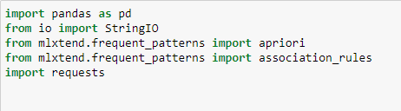Importing Libraries:

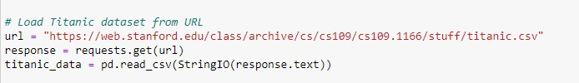Load titanic dataset:

Data preprocessing:

Convert categorical variables to numerical values:

Binning Age and Fare columns for better representation:

Convert all columns to string type for encoding:

Frequent Itemsets Generation:

Association Rules Generation:

Print association rules:

